ADVANCE DEVOPS EXP 6

# Aim : To Build, change, and destroy AWS / GCP /Microsoft Azure/ DigitalOcean infrastructure Using Terraform. (S3 bucket or Docker) fdp.

# Part A: Creating docker image using terraform

**Step 1:**Check Docker functionality

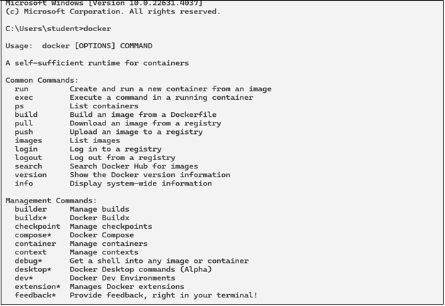

Check for the docker version with the following command.

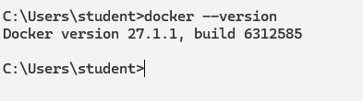

# Create a folder named ‘Terraform Scripts’ in which we save our different types of scripts which will be further used in this experiment.

**Step 2**:

Creating a new folder named ‘Docker’ in the ‘TerraformScripts’ folder.

Creating a new docker.tf file using Atom editor and write the following contents into.

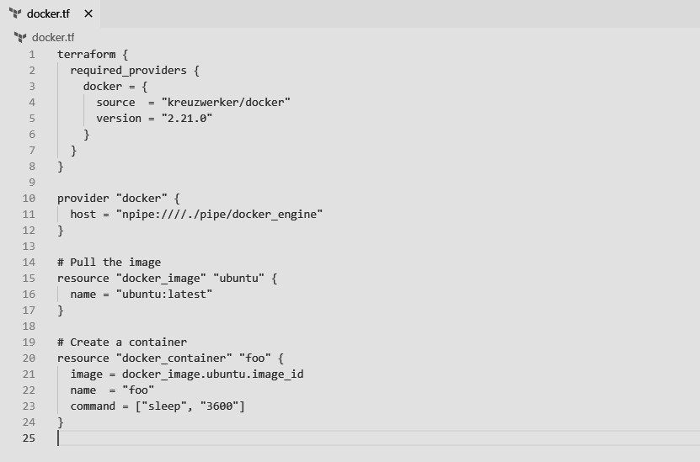

This will create a Ubuntu Linux container

**Step 3:** Execute Terraform Init command to initialize the resources

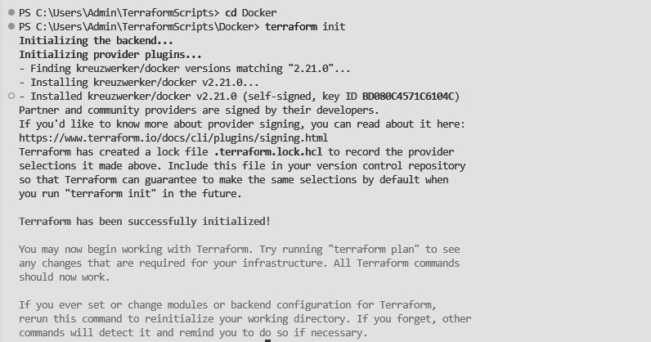

**Step 4:** Execute Terraform plan to see the available resources

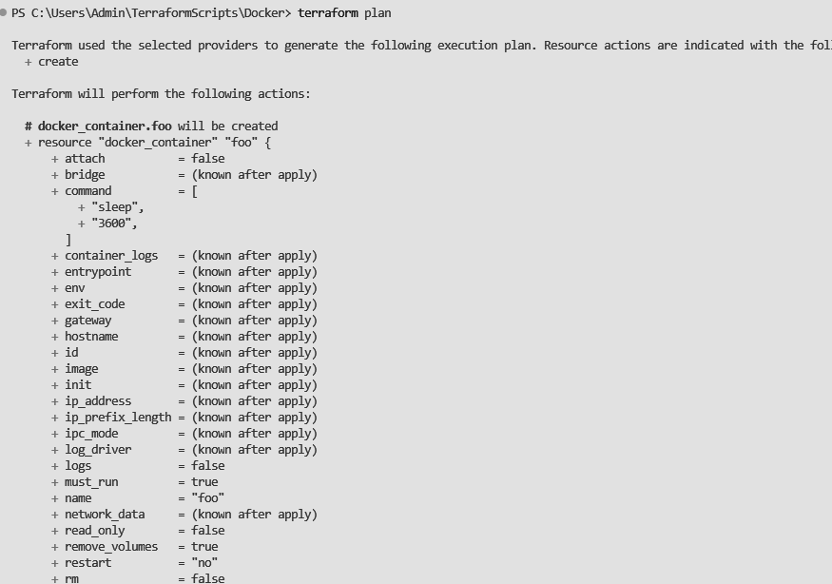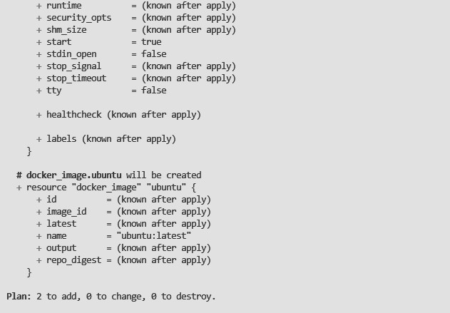

**Step 5**: Execute Terraform apply to apply the configuration, which will automatically create and run the Ubuntu Linux container based on our configuration. Using command : **“terraform apply”**

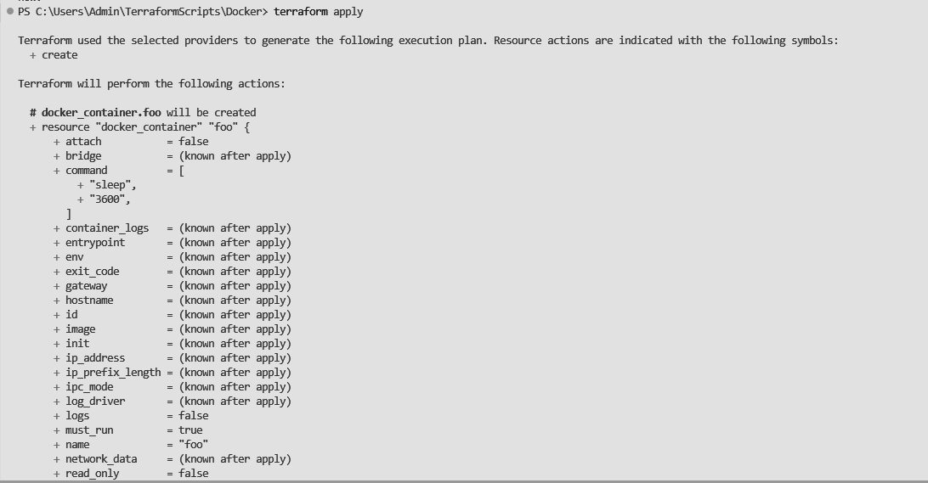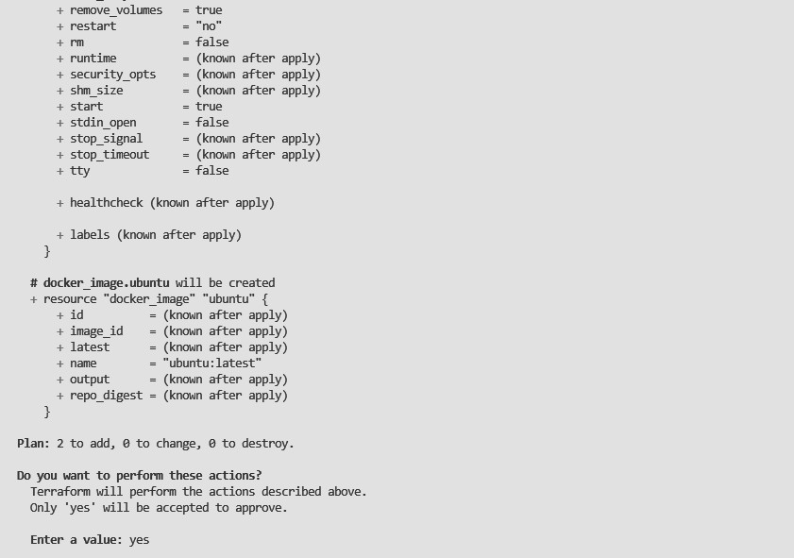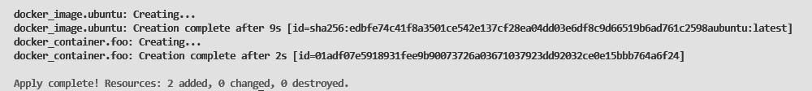

Before Executing Apply step:



After Executing Apply step:



**Step 6:** Execute Terraform destroy to delete the configuration, which will automatically delete the Ubuntu Container.

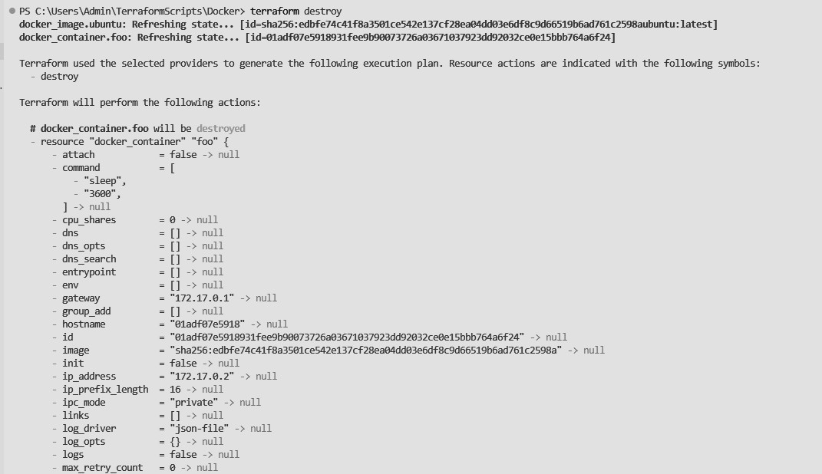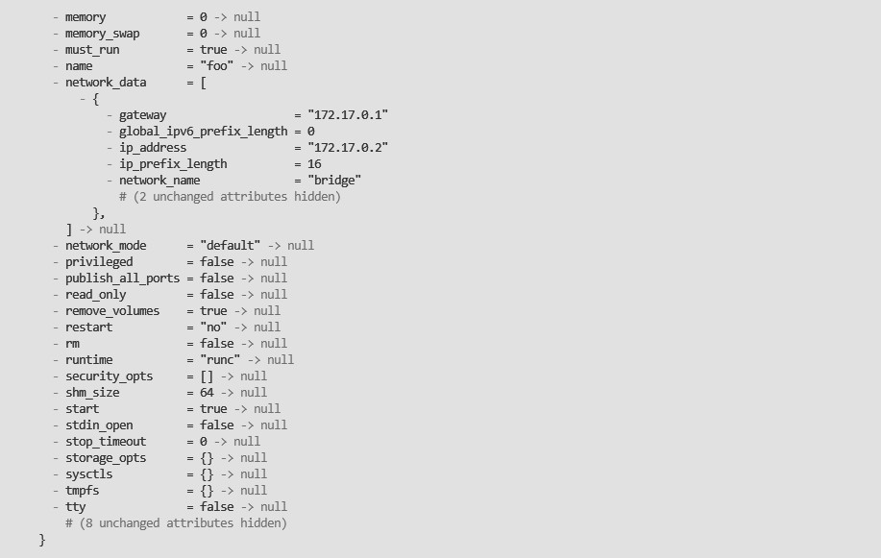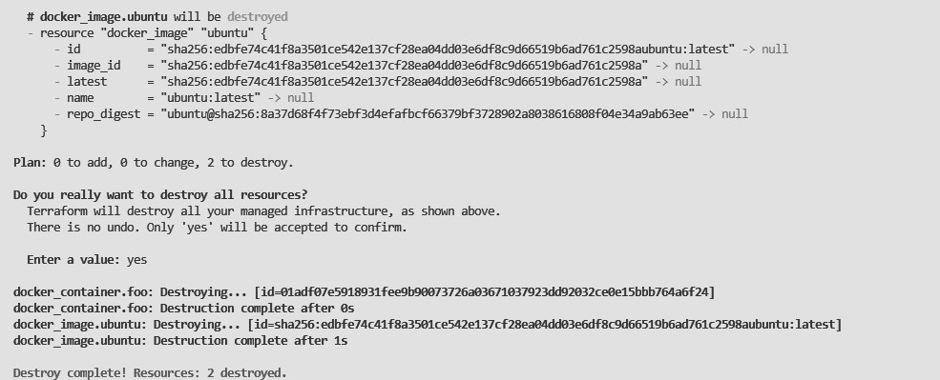

Docker images After Executing Destroy step

